**TABLEAU DATAVIZ CHALLENGE 2021**

-Water And Sanitation

Quality Parameters:

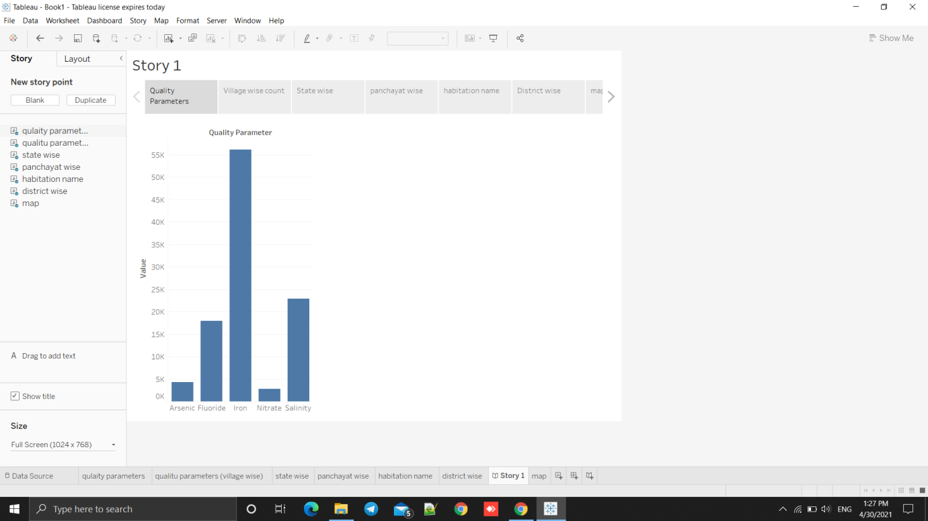

Village Wise:

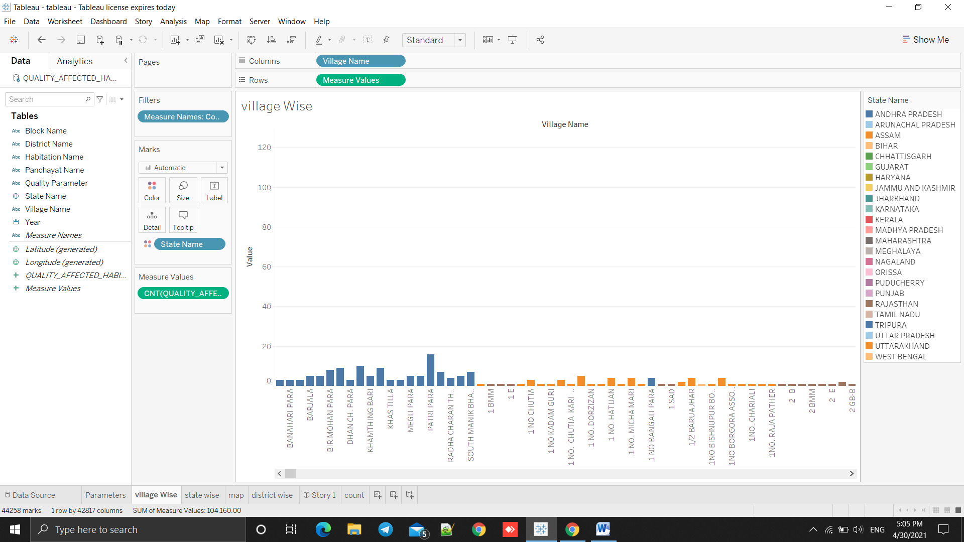

State wise:

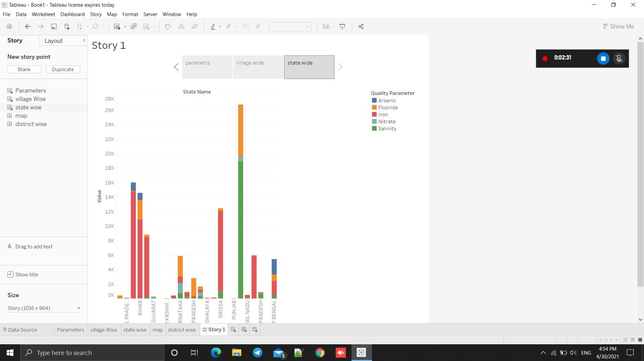

Map (STATE ):

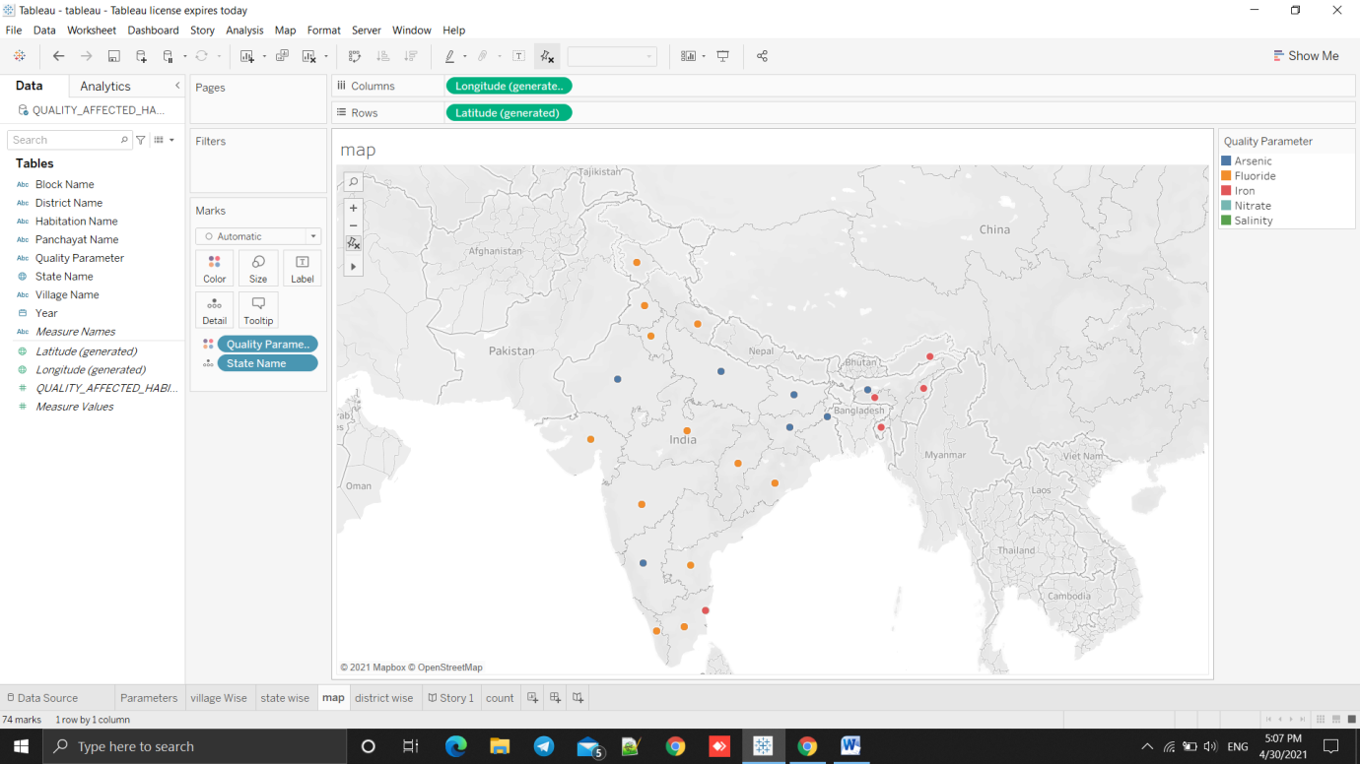

Village(COUNT):

